Merchant Management Use Case

Submitted to

Alpha Payments Cloud


Tarang Software Technologies Private Limited
Tarang Towers,
#400/2, Whitefield 100 ft road,
Hoody circle,
Bangalore, India
Phone: +91-80-41157777
WEB: www.tarangtech.com

© This document is exclusive property of Tarang software Technologies Private Limited. No part of this may reproduced in any form without written permission.

Document Change History

Ver# | Editor | Date | Reviewer | Approver | Changes made
0.1 | Sadanandha | 11th Sept 2012 | Bindu |  | Draft version
1.0 | Sadanandha | 12th Sept 2012 | Bindu |  | Base version
1.01 | Sadanandha | 24th Sept 2012 | Ronan |  | Updated with review comments
1.02 | Sadanandha | 29th Sept 2012 | Ronan |  | Updated with 27th review comments
Table of Contents
1 Introduction 4
2 Use Case: Add merchant 4
2.1 User Interface Information 7
2.1.1 User Interface details for Add Merchant 7
3 Use Case: EDIT merchant 11
3.1 User Interface Information 14
3.1.1 User Interface details for Edit Merchant 14
3.1.2 Validations for View Edit Merchant 15
4 Use Case: Approve/REJECT merchant 17
5 Use Case: Merchant field mapping 18
5.1 User Interface Information 19
5.1.1 User Interface details for Merchant Field Mapping 19
6 Use Case: Add Merchant fIeld 19
6.1 User Interface Information 20
6.1.1 User Interface details for Add Merchant Field 20
6.1.2 Validations for Add Merchant Field 21
7 Use Case: PAY PAGE CONFIGURATION 22
7.1 User Interface Information 23
7.1.1 User Interface details for Pay Page Configuration 24
7.1.2 Validations for Pay Page Configurations 24

Introduction

This document describes all the use cases for Manage Merchants It includes Add Merchant, Edit Merchant, Approve Merchant, Merchant Field mapping and Pay Page configuration.

Use Case: Add merchant

Title | Add Merchant
Requirement ID | RID-1111
Actors | System Admin, APC User with appropriate privilege to create merchant
Description | Allows the actor to add a merchant into the APC system
Use case trigger | - Actor chooses to click on “Add Merchant” button from the Merchant listing screen (Manage Merchants >> Add Merchant)
Main flow / Flow of Events | - System shall navigate the actor to the Add Merchant screen along with the following fields to be captured.  Merchant Business Details  - Business Name  - Display Name  - Bank ID  - Corporate ID e  - Currency  - Language  - Website Name  - Merchant Time Zone  - DST  - Virtual POS  - MCC  - MCP(Standard or Special)  - DCC  - FSS  - Hosted Pay Page Customization  - Encrypt Request/Response  - Checksum Enabled  - Address Validation  - Level 2/3 Data  - Airline Data  - License Validity  - Valid From  - Valid To  - System Generated or Custom (Custom Name)  - Auto Renew  - Soft Descriptor  - Descriptor (City or URL or Telephone with the corresponding value)  - Charge Descriptor  - Contact Details (Business)  - Title  - First Name  - Last Name  - User Name  - Mobile Number  - Phone Number  - Primary Email  - Secondary Email  - Address1  - Address2  - Country  - State/Province  - City  - Zip/Postal Code  - Contact Details (Technical/Helpdesk 24 / 7)  - Level 1  - Name  - Email Address  - Contact No  - Level 2  - Name  - Email Address  - Contact No  - Actor shall enter the relevant information & Click on Next.  - System shall validate the information entered & save the details in the DB and shall navigate the actor to KYC Checklist screen along with the following fields to be captured.  - Is KYC Validated by Bank(Yes/No)  - Company Documents  - Public Quoted Company(Yes or No) if yes Stock Symbol and Stock Exchange  - Company Registration Number  - VAT Registration No  - Authorised Person  - Director Name1  Document Type(Utility Bill or Bank Statement or Government Document) Description  - Director Name2  Document Type(Utility Bill or Bank Statement or Government Document) Description  - Beneficial Owner(Yes or No) If yes Name and Address  - KYC Document Location  - Remarks  - Actor shall enter the relevant information & Click on Save  - System shall validate the information entered & save the details in the DB. The respective merchant should get listed as part of the merchant list in the manage merchants screen.
Sub-flow/Alternate Flows/ Scenarios | 5a. If the Actor enters invalid data, the system will navigate the actor to the same screen  With appropriate error message.
Assumptions | APC User with appropriate privilege to create merchant in the system
Pre-conditions | The actor is logged in to the application and has appropriate privileges.
Post-conditions | - Add - New Merchant will successfully be created in the system and the system will navigate the actor to Manage Merchants screen.  - New Merchant will be listed in the PENDING_FOR_APPROVAL status.
Status | Open
Issues
Business Rules | MID should get generated uniquely across the merchants.  When the actor selects the Custom and gives the custom name, the system should create the MID with the combination of custom name and randomly generated string.  Business Name should be unique among the merchants. and Display Name can be the same for different merchants  Checksum is used for the security of data transmission from merchant site to APC PG. When the merchant is sending the order information to APC PG, the merchant calculates the checksum value for the order data by using algorithm provided by PG and sends the checksum value along with the order information to APC, then APC again calculates the checksum value for order information at its end and validates with the checksum sent by merchant. If both are same, the transaction will be processed, if not the transaction is rejected.  License Validity: During Transaction Processing for the particular merchant, If the transaction date is beyond the valid To and valid From dates given in the merchant registration, the transaction will be rejected. If Auto Renew is enabled during merchant registration, the Valid From and Valid To fields will be overridden once those dates are crossed.  KYC Validation done by Bank: If the KYC validation is already handled by Bank, there is an option for setting this to bypass the KYC validation in APC. The field  “Is KYC Validated by Bank” shall be used for the same. If the value is”Yes” then the KYC validation is bypassed in the APC. But the user can enter the KYC details for records.  While approving of the merchant, the KYC related verification parameters will be by default checked for( Verified, Directors name and address , Beneficial owners identified) if the “Is “KYC Validated by Bank” field value is selected.  There will be no default user created for the new merchant during the merchant on boarding process.  There will be API only access users created for merchant, these users will not have login access to the portal application. The API only user will be created as a new user for the associated merchant with no portal access. By default access is provided to all API, unless selected to exclude the access permission from the list of APIs. The API user will be part of later release

User Interface Information

User Interface details for Add Merchant

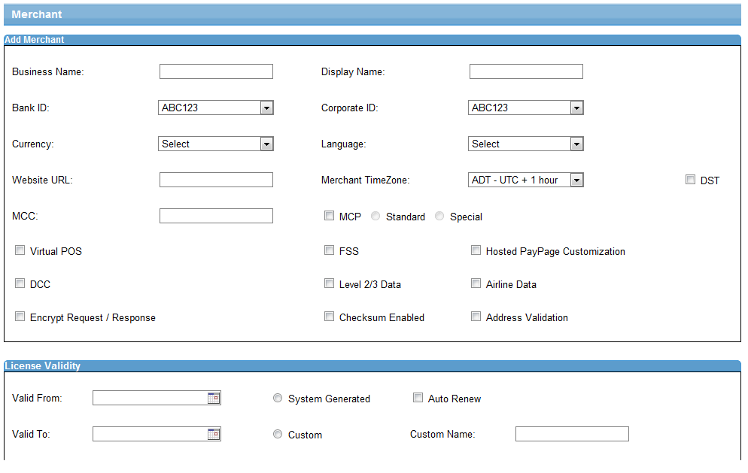
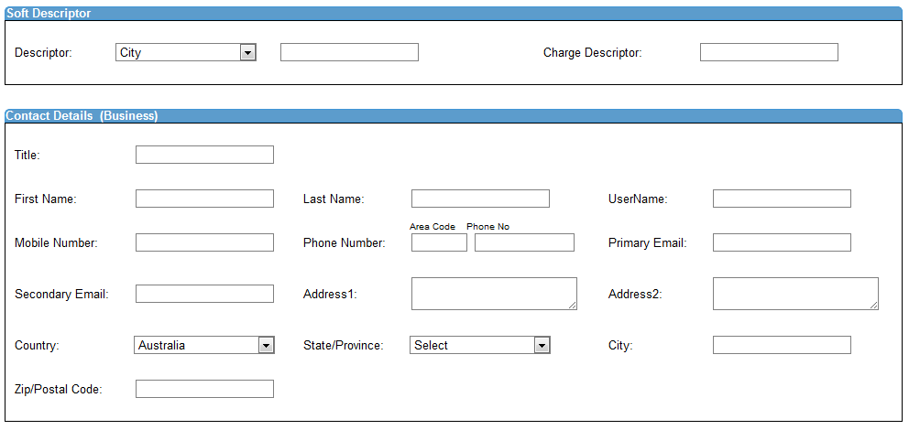

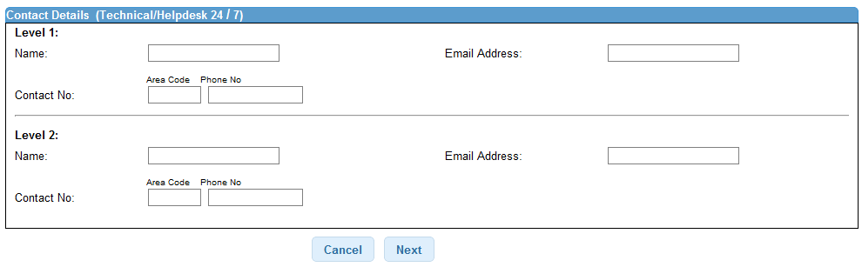

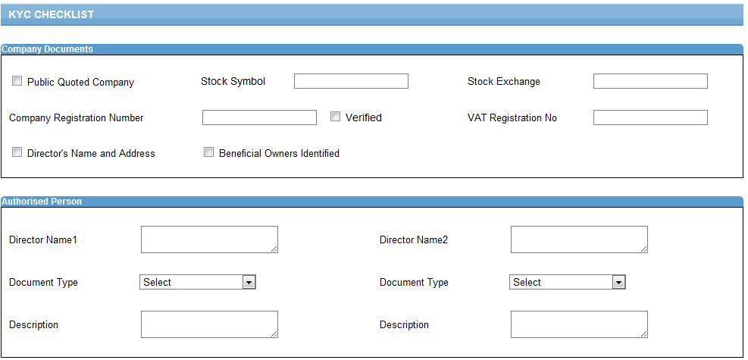

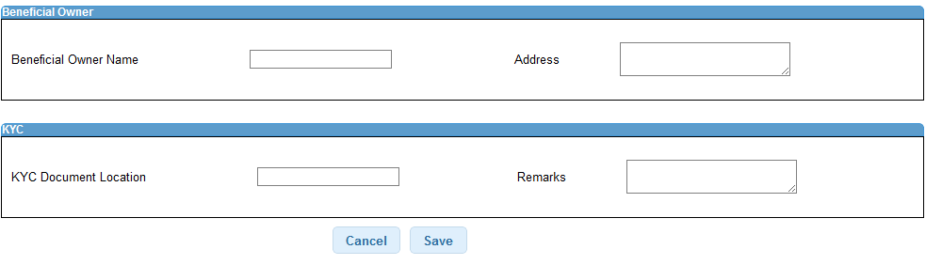

Validations for View Add Merchant

Parameter Name | Field Type | Special characters | Validations | Field Length | Possible Values | Additional Condition | Mandatory
Business Name | Textbox
Display Name | Textbox
Bank Id | Dropdown
Corporate Id | Dropdown
Currency | Dropdown
Language | Dropdown
Website Name | Textbox
Merchant Time Zone | Dropdown
DST | Check box
Virtual POS | Check box
MCC | Textbox
MCP  (Standard or Special) | Check box  Radio
DCC | Check box
FSS | Check box
Hosted Pay Page Customization | Check box
Encrypt Request/Response | Check box
Airline Data | Check box
Level 2/3 Data | Check box
Checksum Enabled | Check box
Valid From | Textbox  Date picker
Valid To | Textbox  Date picker
Auto Renew | Checkbox
System Generated or Custom | Radio button
Custom Name | Textbox
Descriptor | Drop down
value | Text box
Charge Descriptor | Text box
Title | Text box
First Name | Text box
Last Name | Text box
User Name | Text box |  | optional
Mobile Number | Text box
Phone Number | Text box
Primary Email | Text box
Secondary Email | Text box
Address1 | Text box
Address2 | Text box
Country | Drop down
State/Province | Drop down
City | Text box
Zip/Postal Code | Text box
KYC CHECKLIST

Public Quoted Company | Check box
Stock Symbol | Text box
Stock Exchange | Text box
Company Registration Number | Text box
VAT Registration No | Text box
Director Name1 | Text box
Document Type | Drop down
Description | Text Area
Beneficiary Owner | Check box
Name | Text box
Address | Text Area
Director Name2 | Text box
Document Type | Drop down
Description | Text box
KYC Document Location | Text box
Remarks | Text Area

Use Case: EDIT merchant

Title | Edit Merchant
Requirement ID | RID-1112
Actors | System Admin, APC User with appropriate privilege to edit merchant
Description | Allows the actor to edit an existing merchant in the system
Use case trigger | Actor chooses to double click on a selected row or click on “Edit Merchant” button from the Merchant listing screen (Manage Merchants >> Edit Merchant)
Main flow / Flow of Events | System shall navigate the actor to the Edit Merchant screen along with the following fields to be updated.  details of the fields with the existing values shown are  - Merchant Business Details  - Business Name  - Display Name  - Bank Code  - Corporate Code  - Currency  - Language  - Website Name  - Merchant Time Zone  - DST  - Virtual POS  - MCP(Standard or Special)  - DCC  - FSS  - Hosted Pay Page Customization  - Encrypt Request/Response  - Checksum Enabled  - AVS  - Level 2/3 Data  - Airline Data  - License Validity  - Valid From  - Valid To  - System Generated or Custom (Custom Name)  - Auto Renew  - Soft Descriptor  - Descriptor (City or URL or Telephone with the corresponding value)  - Charge Descriptor  - Contact Details (Business)  - Title  - First Name  - Last Name  - User Name  - Mobile Number  - Phone Number  - Primary Email  - Secondary Email  - Address1  - Address2  - Country  - State/Province  - City  - Zip/Postal Code  - Contact Details (Technical/Helpdesk 24 / 7)  - Level 1  - Name  - Email Address  - Contact No  - Level 2  - Name  - Email Address  - Contact No  - Actor shall modify one or more information & Click on Next.  - System shall validate the information entered & save the details in the DB and shall navigate the actor to KYC Checklist screen along with the existing values  - Company Documents  - Public Quoted Company(Yes or No) if yes Stock Symbol and Stock Exchange  - Company Registration Number  - VAT Registration No  - Authorised Person  - Director Name1  Document Type(Utility Bill or Bank Statement or Government Document) Description  - Beneficiary Owner(Yes or No) If yes Name and Address  - Director Name2  Document Type(Utility Bill or Bank Statement or Government Document) Description  - Beneficiary name  - KYC Document Location  - Remarks  - Actor shall modify one or more fields & Click on Save  - System shall validate the information entered & save the details in the DB. The respective merchant should get listed as part of the merchant list in the manage merchants screen.
Sub-flow/Alternate Flows/ Scenarios | If the Actor enters the invalid data, the system will navigate the actor to the same screen with appropriate error message.  If FSS is selected for the merchant, the FSS integration interface parameters are configured for the merchant. Refer the FSS integration document” FSS Integration Data Elements-High Level Identified.txt” for the request and response parameters used for the integration.  In the FSS screen the merchant can add one or multiple rule sets, If multiple rule set is selected, there shall be some sort of combined decision e.g. if an account is on the white list it doesn't mean it will automatically pass if the fraud score is above the designated threshold
Assumptions | APC User with appropriate privilege to edit merchant in the application
Pre-conditions | The actor is logged in to the application.
Post-conditions | The modified details will successfully be updated in the system and the system will navigate the actor to Manage Merchants screen.
Status | Open
Issues
Business Rules | MID, System Generated, Custom, Custom Name cannot be modified.  Bank Id, Corporate Id is editable before merchant approval  KYC information cannot be modified for the Approved Merchants.  Editable fields that can be changed after approval are: Stock symbol and Stock Exchange.  The director or beneficial owner name and address can change; the changed name and address need to be verified. And the old director details shall be saved in history records  If the bank id or corporate id is to be changed, this is considered as new merchant creation and the old merchant is retained with the previous bank id and corporate id and is deactivated.

User Interface Information

User Interface details for Edit Merchant

Same as Add Merchant

For FSS integration interface for the merchant:

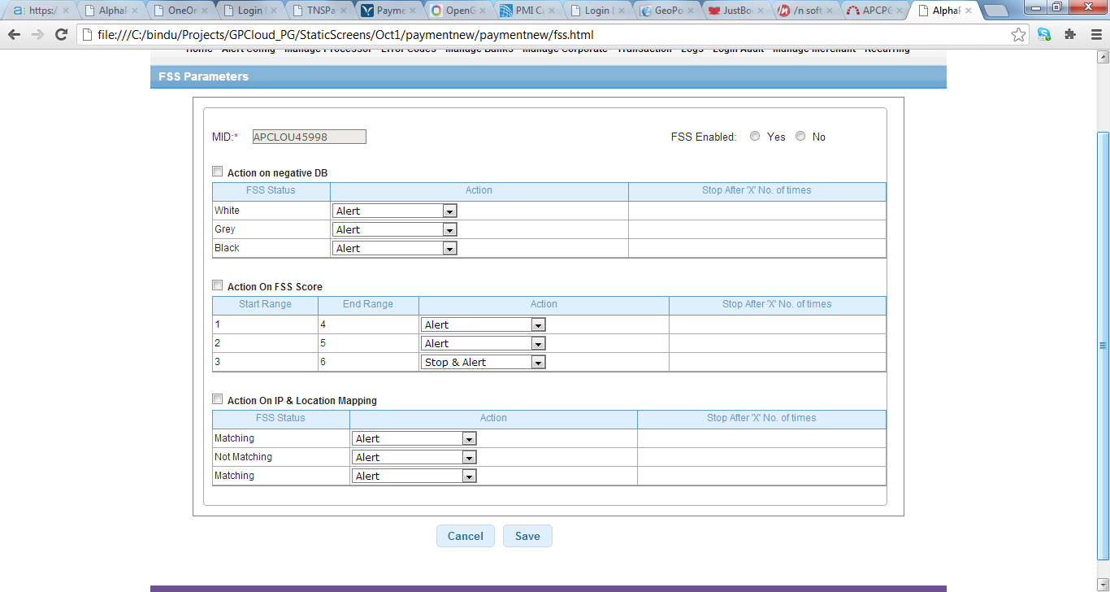

Validations for View Edit Merchant

Parameter Name | Field Type | Special characters | Validations | Field Length | Possible Values | Additional Condition | Mandatory
Business Name | Textbox
Display Name | Textbox
Bank Code | Dropdown
Corporate Code | Dropdown
Currency | Dropdown
Language | Dropdown
Website Name | Textbox
Merchant Time Zone | Dropdown
DST | Check box
Virtual POS | Check box
MCP  (Standard or Special) | Check box  Radio
DCC | Check box
FSS | Check box
Hosted Pay Page Customization | Check box
Encrypt Request/Response | Check box
Airline Data | Check box
Level 2/3 Data | Check box
Checksum Enabled | Check box
Valid From | Textbox  Date picker
Valid To | Textbox  Date picker
Auto Renew | Checkbox
System Generated or Custom | Radio button
Custom Name | Textbox
Descriptor | Drop down
value | Text box
Charge Descriptor | Text box
Title | Text box
First Name | Text box
Last Name | Text box
User Name | Text box
Mobile Number | Text box
Phone Number | Text box
Primary Email | Text box
Secondary Email | Text box
Address1 | Text box
Address2 | Text box
Country | Drop down
State/Province | Drop down
City | Text box
Zip/Postal Code | Text box
KYC CHECKLIST

Public Quoted Company | Check box
Stock Symbol | Text box
Stock Exchange | Text box
Company Registration Number | Text box
VAT Registration No | Text box
Director Name1 | Text box
Document Type | Drop down
Description | Text Area
Beneficiary Owner | Check box
Name | Text box
Address | Text Area
Director Name2 | Text box
Document Type | Drop down
Description | Text box
KYC Document Location | Text box
Remarks | Text Area

Use Case: Approve/REJECT merchant

Title | Approve/Reject the Merchant
Requirement ID | RID-1113
Actors | System Admin, APC User with appropriate privilege to approve the merchant
Description | Allows the Actor to either Approve or Reject the Merchant Registration.
Use case trigger | - Actor clicks on the Approve/Reject link/button at the bottom of the Merchant details listing grid (Manage Merchants >> Approve/Reject)  .
Main flow / Flow of Events | - On clicking the Approve/Reject, System shall navigate the actor to Approve/Reject Merchant screen with the details captured during Merchant Registration as read only along with the following additional fields in KYC Checklist screen as editable.  - Verified  - Director's Name and Address  - Beneficiary Owners Identified  - Remarks  Actor verifies the details with the physical documents submitted by the Merchant,  ticks the corresponding checkboxes and enters the comments in Remarks section and clicks on either Approve or Reject button.  .
Sub-flow/Alternate Flows/ Scenarios | If the actor doesn’t give the remarks and clicks on Approve/Reject buttons, the appropriate error message will be shown on the same screen.
Assumptions
Pre-conditions | The actor is logged in to the application and has the privilege to approve the merchant.
Post-conditions | System will navigate the actor to the merchant listing screen.  The merchant status will be displayed as APPROVED/REJECTED.
Status | Open
Issues | None
Business Rules | Remarks are mandatory for both (Approve and Reject).  For approving the merchant, the actor has to tick all the check boxes.  If the KYC check list is bypassed , then the KYC tick box will be defaulted to selected mode

Use Case: Merchant field mapping

Title | Merchant Field Mapping
Requirement ID | RID-1114
Actors | System Admin, APC User with appropriate privilege for the merchant field mapping listing
Description | Allows the Actor to map the APC fields to merchant feilds.
Use case trigger | - Actor clicks on the Merchant Field Mapping link/button at the bottom of the Merchant details listing grid (Manage Merchants >> Merchant Field Mapping)  .
Main flow / Flow of Events | - On clicking the Merchant Field Mapping link/button, System shall navigate the actor to Merchant field mapping screen where all the merchant fields configured will be displayed in the listing in the below mentioned format:  - Merchant Field  - Field Type  - Mandatory  - Field Length  - Default Value  - Auth Mode  - Level(Level2 or Level 3)  - COMM Mode(WEB)  - Url Type (Request / Response)  - Txn Type (Sale/Refund/Auth Query)  - Sequence  Add and delete buttons/links will be shown at the bottom of the grid.
Sub-flow/Alternate Flows/ Scenarios | - When the Actor clicks on Add button System will be navigating the actor to Add Merchant Field screen.  - If the Actor selects the row and clicks on Delete button, the corresponding field will be deleted from the system.
Assumptions | Actor is logged into the system & and has the view Merchant field mapping permission
Pre-conditions | Actor is logged into the system.
Post-conditions | None
Status | Open
Issues | None
Business Rules | -

User Interface Information

User Interface details for Merchant Field Mapping

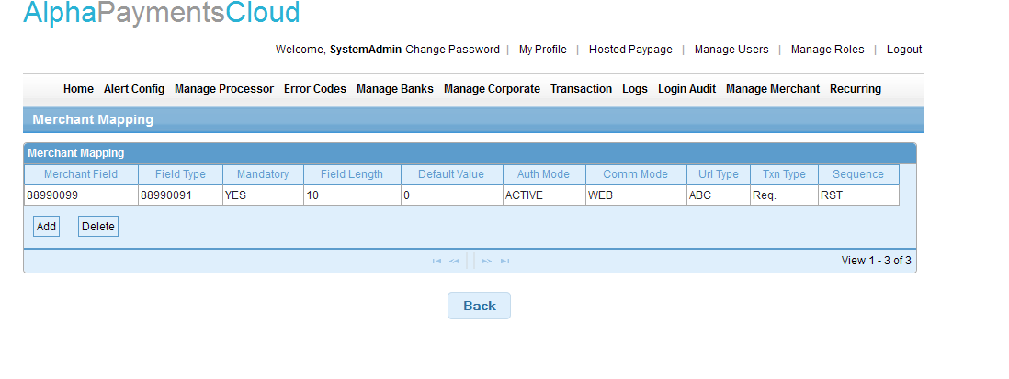

Use Case: Add Merchant fIeld
Title | Add Merchant Field
Requirement ID | RID-1115
Actors | System Admin, APC User with appropriate privilege to add merchant field mapping.
Description | Allow the actor to map the merchant field to APC field. These fields will be used to get the transaction parameters while processing the transactions coming from the particular merchant.
Use case trigger | 1. Actor clicks on the Add merchant field button/link in the merchant fields listing grid
Main flow / Flow of Events | - System shall pop a modal dialog pop up along with the following information to be captured:  - MID  - Comm. Mode  - Airline (Yes/No)  - Level (Level 2/Level 3)  - Auth Mode  - URL Type  - Txn Type  - Field Name  - Field Value Length  - Default Value  - Field Type  - Is Mandatory (Yes /No)  - Sequence No  - Merchant Field
Sub-flow/Alternate Flows/ Scenarios | If the Actor enters the invalid data and clicks on Save button, then System will navigate the actor to the same screen with appropriate error message.
Assumptions | Actor is logged in to the System and has the Add Merchant Field permission.
Pre-conditions | Actor is logged in to the System and has the Add Merchant Field permission
Post-conditions | The added field will be successfully saved into the system and the system navigates the actor to Merchant mapping field screen with the newly added field details.
Status | Open
Issues | Not having much clarity on Auth Mode.  Need to get clarified regarding Auth Mode how this is being used in this context.
Business Rules | Merchant Field Name and Sequence Number should be unique for the MID, Comm Mode Auth Mode, URL Type and Txn Type combination.  Field Value length cannot be more than the corresponding APC Field length.

User Interface Information

User Interface details for Add Merchant Field

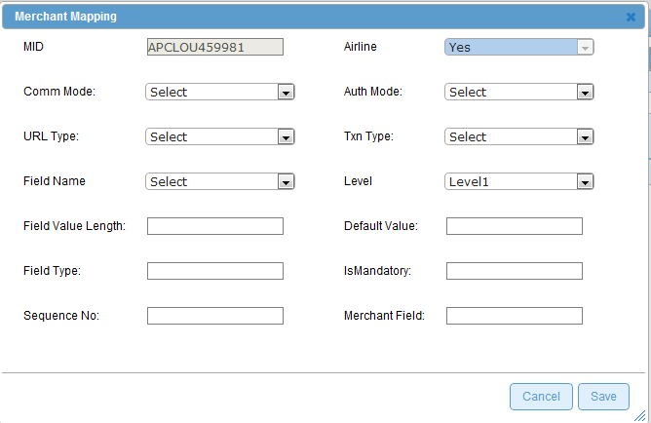

Validations for Add Merchant Field

Id | Parameter Name | Field Type | Special characters | Validations | Field Length | Possible Values | Additional Condition | Mandatory
1 | MID | Label (Read Only)
2 | Comm. Mode | Drop down
3 | Auth Mode | Dropdown
4 | URL Type | Dropdown
5 | Txn Type | Dropdown
6 | Airline | Drop down |  |  |  | Yes/No
7 | Level | Drop down |  |  |  | Select/Level 2/ Level 3
8 | Field Name | Dropdown
9 | Field Value Length | Textbox
10 | Default Value | Drop down
11 | Field Type | Text box
12 | Is Mandatory | Text box
13 | Sequence No | Text box
14 | Merchant Field  Name | Text box

Use Case: PAY PAGE CONFIGURATION
Title | Pay Page configuration
Requirement ID | RID-1116
Actors | System Admin, APC User with appropriate privilege to configure pay page configuration.
Description | Allow the actor to configure the pay page settings for the merchant
Use case trigger | Actor clicks on the Pay Page Configuration button/link on the merchant listing grid
Main flow / Flow of Events | System shall navigate the actor to the Pay Page configuration screen along with the following details to be captured.  - Basic Configuration  - Card Type  - Response Method  - Response URL  - Pay Page Appearance: Color & Style:  Back Ground Color  - Font Style  - Font Size  - Primary Text Color  - Upload Logo  - iframe or New Page  - Height and Width ( if iframe is selected)  - Data Fields  - Display item Details  - Display customer Details  - Display Shipping/Bill Details  - Display Merchant Details  - Input Fields  Display Address Input  - Configure Email Receipts  - Send Email if Transaction approves  - Send Email if Transaction declines  - Receipt Appearance  - Email Format (Plain Text or HTML)  - Include Line item Details  - Include Shipping/Billing Details  - Language  - Email Text  The actor enters or selects the relevant information and clicks on Save button and all the Pay Page configuration information will be saved successfully into the System.  A Preview button will provided for the user to view the pay page configuration selected
Sub-flow/Alternate Flows/ Scenarios | If the Actor enters the invalid data and clicks on Save button, then System will navigate the actor to the same screen with appropriate error message.  Click on the Preview button will allow the user to view the pay page for the selected configuration
Assumptions | Actor is logged in to the System and has the Pay Page Configuration permission.
Pre-conditions | Actor is logged in to the System appropriate permission
Post-conditions | The added field will be successfully saved into the system.
Status | Open
Issues | None
Business Rules | Back Ground Color and Primary Text color cannot be same.  The Hosted Pay Page has to be displayed according to these configuration settings during transaction processing.

User Interface Information

User Interface details for Pay Page Configuration
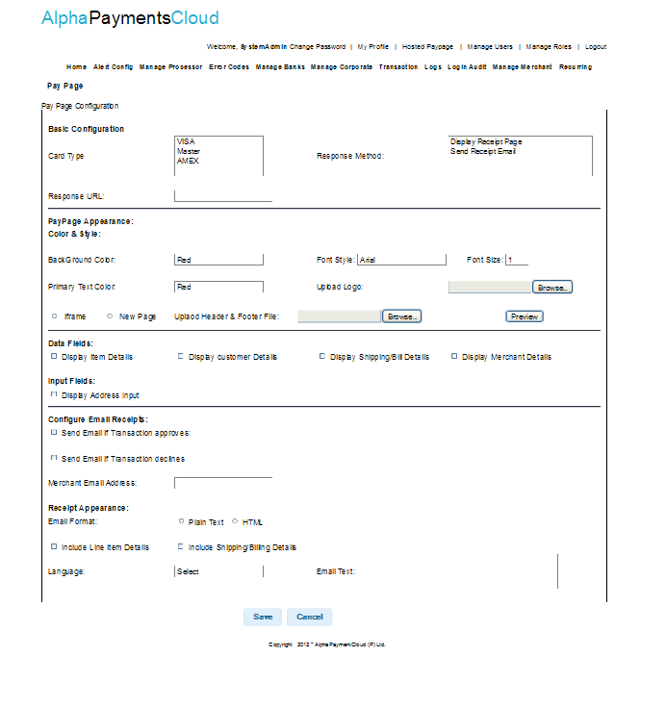

Validations for Pay Page Configurations

Id | Parameter Name | Field Type | Validations |  | Field Length | Possible Values | Additional Condition | Mandatory
 | Card Type  Response Method  Response URL  Back Ground Color  Font Style  Font Size  Primary Text Color  Upload Logo  iframe or New Page  Height , Width  Display item Details  Display customer Details  Display Shipping/Bill Details  Display Merchant Details  Display Address Input  Send Email if Transaction approves  Send Email if Transaction declines  Email Format (Plain Text or HTML)  Include Line item Details  Include Shipping/Billing Details  Language  Email Text | Multiple select  Multiple select  Text box  Drop down  Drop down  Drop down  Drop down  Input for Browsing  Radio button  Textbox  Checkbox  Checkbox  Checkbox  Checkbox  Checkbox  Checkbox  Checkbox  Radio  Checkbox  Checkbox  Drop down  Text Area |  |  |  | If iframe is selected, height and width option to be entered

Note: Interface for the Integration for the multiple providers shall be a handled in the later release, this is a change request and the details required for the implementation are the provider names, request and response parameters for each provider to be supported for the MCP, DCC, and FSS, Address verification. Merchant Boarding API will also be part of the later releases.

